**META SCIFOR ASSIGNMENT**

**1)Supervised Learning :-** Supervised machine learning is a type of machine learning where the model is trained on labeled data. This means that the training data includes both the input features and the corresponding correct output. The model learns to map the inputs to the outputs, and once trained, it can make predictions on new, unseen data.

**Example:-**

**Predicting House Prices :-** Predicting house prices is a common task in supervised machine learning, specifically in regression analysis, where the goal is to predict a continuous target variable (house price) based on several input features (e.g., size of the house, number of bedrooms, age of the house, etc.).

**2) Unsupervised Learning :-** Unsupervised machine learning is a type of machine learning where the algorithm is trained on data that does not have labeled responses. The goal is to find hidden patterns or intrinsic structures in the input data. Common techniques include clustering and dimensionality reduction.

**Example:-**

**Customer Segmentation :-** Customer segmentation is a key strategy in marketing that involves dividing a company's customer base into distinct groups or segments, each characterized by specific traits, behaviors, or needs. The goal is to tailor marketing efforts and product offerings to each segment to maximize engagement, satisfaction, and profitability.

**Key Concepts in Customer Segmentation**

1. **Segmentation Variables:**
   * **Demographic:** Age, gender, income, education, occupation.
   * **Geographic:** Country, region, city, postal code.
   * **Psychographic:** Lifestyle, values, interests.
   * **Behavioral:** Purchase history, spending patterns, brand loyalty, product usage.
2. **Segmentation Approaches:**
   * **Rule-Based Segmentation:** Predefined rules to segment customers (e.g., customers under 30, customers who spend more than $100 monthly).
   * **Data-Driven Segmentation:** Using machine learning algorithms to identify patterns and segment customers based on their data.

**Machine Learning Techniques for Customer Segmentation**

1. **Clustering:**
   * **K-Means Clustering:** Divides the data into K distinct clusters based on distance to the cluster centroids.
   * **Hierarchical Clustering:** Builds a tree of clusters by iteratively merging or splitting existing clusters.
   * **DBSCAN (Density-Based Spatial Clustering of Applications with Noise):** Groups together points that are closely packed together, marking points in low-density regions as outliers.
2. **Dimensionality Reduction:**
   * **Principal Component Analysis (PCA):** Reduces the dimensionality of the data while preserving as much variance as possible.
   * **t-SNE (t-Distributed Stochastic Neighbor Embedding):** Reduces dimensions for visualization in a way that preserves local structure.
3. **Association Rule Mining:**
   * Identifies relationships between variables in large datasets (e.g., Market Basket Analysis).

**3) Reinforcement Learning :-** Reinforcement learning (RL) is a type of machine learning where an agent learns to make decisions by interacting with an environment. The agent receives rewards or penalties based on its actions and aims to maximize the cumulative reward over time. Unlike supervised learning, RL does not require labeled input/output pairs and focuses on learning from experience.

### Key Concepts in Reinforcement Learning

1. **Agent:** The learner or decision-maker.
2. **Environment:** The external system with which the agent interacts.
3. **State:** A representation of the current situation of the agent.
4. **Action:** The choices available to the agent.
5. **Reward:** Feedback from the environment based on the agent's actions.
6. **Policy:** The strategy used by the agent to decide actions based on the state.
7. **Value Function:** Estimates the expected cumulative reward from a given state or state-action pair.
8. **Q-Value (Action-Value):** Estimates the expected cumulative reward of taking a specific action in a specific state and following the optimal policy thereafter.

### Example: Q-Learning to Solve a Gridworld Problem

#### Problem Description:

We have a simple gridworld environment where an agent needs to find the shortest path from a start state to a goal state while avoiding obstacles. The agent can move up, down, left, or right.

#### Gridworld Environment:

* A 5x5 grid.
* Start state: (0, 0)
* Goal state: (4, 4)
* Obstacles: (1, 1), (2, 2), (3, 3)
* Rewards: +1 for reaching the goal, -1 for hitting an obstacle, 0 otherwise.

#### Q-Learning Algorithm:

Q-learning is a model-free RL algorithm that learns the value of an action in a particular state. The agent updates its Q-values using the Bellman equation:

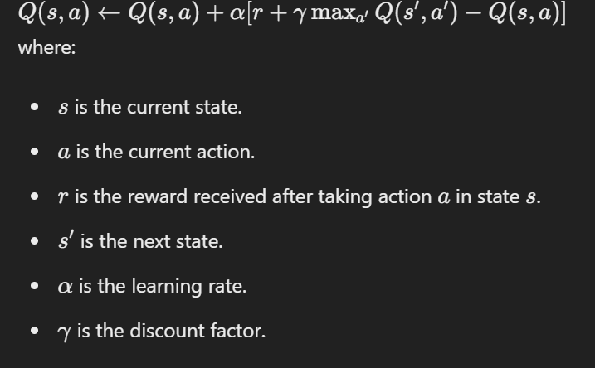

**4)Classification vs Regression vs Clustering**

**Classification**

**Objective:** Classification involves predicting a categorical label for a given input based on training data. The goal is to assign input data to one of several predefined classes.

**Examples:**

* Spam detection in emails (spam or not spam)
* Image recognition (e.g., identifying animals in pictures)
* Medical diagnosis (e.g., classifying patients as having a disease or not)

**Common Algorithms:**

* Logistic Regression
* Decision Trees
* Random Forests
* Support Vector Machines (SVM)
* k-Nearest Neighbors (k-NN)
* Neural Networks (e.g., Convolutional Neural Networks for image classification)

**Regression**

**Objective:** Regression involves predicting a continuous numerical value for a given input based on training data. The goal is to model the relationship between input features and the target variable.

**Examples:**

* Predicting house prices based on features like size, location, and age
* Forecasting stock prices
* Estimating the age of a person based on physical attributes

**Common Algorithms:**

* Linear Regression
* Polynomial Regression
* Ridge and Lasso Regression
* Decision Trees and Random Forests (Regression Trees)
* Support Vector Regression (SVR)
* Neural Networks (e.g., Feedforward Neural Networks)

**Clustering**

**Objective:** Clustering involves grouping a set of objects into clusters where objects in the same cluster are more similar to each other than to those in other clusters. Unlike classification, clustering is typically an unsupervised learning task, meaning it doesn't use labeled data.

**Examples:**

* Customer segmentation in marketing
* Document clustering in information retrieval
* Image segmentation in computer vision

**Common Algorithms:**

* k-Means Clustering
* Hierarchical Clustering
* DBSCAN (Density-Based Spatial Clustering of Applications with Noise)
* Gaussian Mixture Models (GMM)